**ChapR Manufacturing Quality Assurance Instructions**

Last Updated: 11/12/2014

Supplies Needed:

ChapR to be tested

NXT with LabView personality

NXT with NXT-G personality

9V battery with good charge

9V battery with low charge

Joystick

USB Cable

**Bluetooth Connection, Joystick, WaitForStart Testing**

1. Put 9V battery with good charge in ChapR. Don’t turn the ChapR on yet.
2. 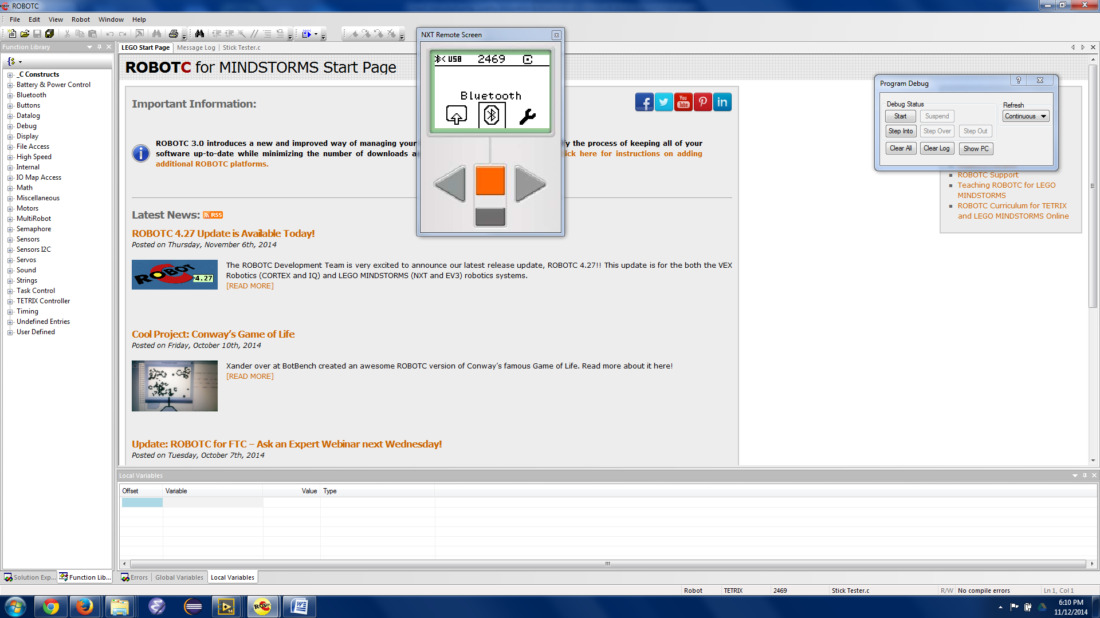Turn on ChapR in pairing mode (hold both power and action for 3 seconds, and ensure that both the blue and green LEDs are flashing in sync).
3. Turn on NXT (with LabView personality).
4. Scroll to Bluetooth icon on NXT by using right and left arrows, and open it.
5. 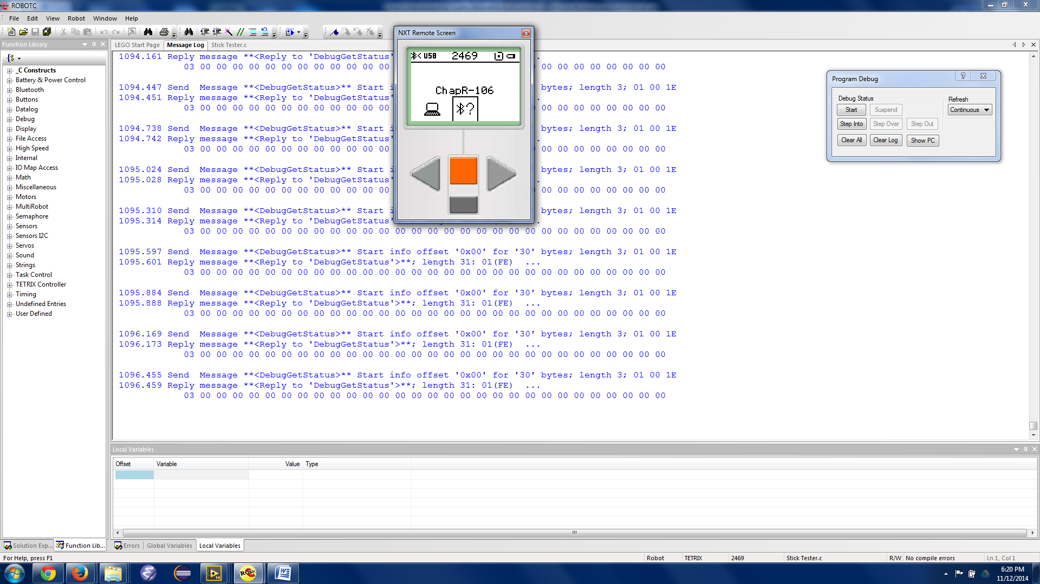Go to My Contacts, and open it. If there are no contacts, it will not open. If there are contacts, click on one, then scroll to delete and delete it. Do the same with all other contacts.
6. Go back to the Bluetooth menu, and scroll to search and click that. The NXT will search for Bluetooth devices for about 30 seconds to 1 minute.
7. Find the name of the ChapR you want to test, and click on that. It should have a icon. Then click Connect. Click the orange button again regardless of if 1, 2, or 3 is selected. The NXT will request a passcode, and accept the default of 1234 by clicking the checkmark icon.
8. The ChapR should take about 5-15 seconds to connect to the NXT, and then make a “squeep” sound indicating it connected.
9. Plug in a joystick into the slot at the top of the ChapR when viewed with the buttons at the bottom.
10. Press the black button to run the “squeep” program.
11. The NXT should start beeping constantly to indicate that WaitForStart is active.
12. Press the black button to release WaitForStart.
13. Test all functions of the joystick and make sure the NXT displays that it received the input. It will show numbers for the buttons, and show the current position of joysticks and the top hat (8 buttons in all directions in a plus sign arrangement). There are 12 buttons: 4 on the top (X, Y, A, B), 4 triggers on top, the Back and Start button, and two buttons that you can activate by pressing down on each joystick.
14. If all functions work, press the red button on the ChapR to end the program.
15. Power the ChapR (by holding the red button down for 3 seconds) and NXT off.

**USB Connection, Personality Testing**

1. Turn on the ChapR (not in pairing mode – just hold red button down for 3 seconds).
2. Turn on the NXT (with NXT-G personality).
3. Plug in USB connector to ChapR’s 1st slot and NXT’s USB slot.
4. Wait for a connection, and then accept default passcode 1234.
5. Disconnect USB to test if ChapR is connected to brick via Bluetooth.
6. Click My Files, then Software Files, then PersonalityTest, then Run.
7. Press the red button on the ChapR once to terminate the program.
8. Power the ChapR and NXT off.

**Low Battery Testing**

1. Put a 9V battery with low charge in the ChapR.
2. Turn on ChapR (not in pairing mode) by holding the red button only for 3 seconds.
3. Make sure the green light is blinking to indicate low battery.

­­